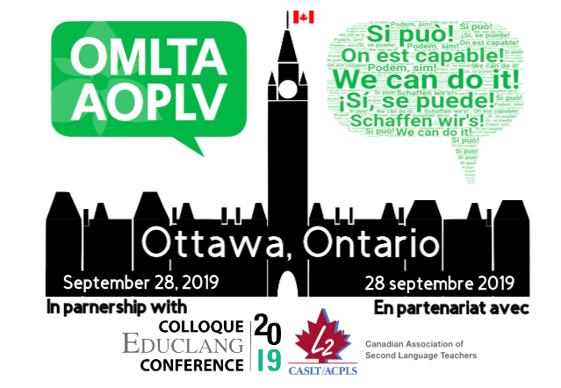

OMLTA/AOPLV FALL CONFERENCE

We can do it! On est capable!
¡Sí, se puede! Si può! Schaffen wir's! Podem, sim!

September 28, 2019
Ottawa, Ontario

Application and Exhibit Booth Contract

Please type in the information and return electronically to omlta@omlta.org.

Company Name:

Exhibitor Contact Person:

Mailing Address:

City/Province: Postal Code:

Telephone:

Email: Website:
___________________________________________________________________________

2018 TABLE RESERVATION:

One 6’ exhibit space - $200.00 (price of $177.00 + 23.00 HST includes one continental breakfast and one lunch)

*OPTIONAL: Should additional space be available, please indicate if you would like to reserve a second table to form a 12’ exhibit space: _____ yes _____ no

Exhibitor space will be considered on a first-come, first served basis. Space will not be reserved until FULL payment has been received.
The deadline for reserving exhibitor space is Monday, August 26, 2019.

Display fees include continental breakfast and lunch for one person for Saturday. Please provide the name of this person below. (This name can be changed by email at a later date, as necessary.)

Name: _________________________________________________________________

Please indicate below additional meals you wish to purchase, at $30.00 per person. Please provide a name for each person. (Names can be changed by email at a later date, as necessary.)

(Quantity) _____________

Name(s): ________________________________________________

________________________________________________

________________________________________________

TOTAL DISPLAY FEE: $200.00
+
TOTAL LUNCH FEE: $ __________

PAYMENT INFORMATION: Credit card and cheque are accepted (OMLTA HST #R104001029)

Charge My: □ Visa □ MasterCard □ American Express

□ A cheque will be sent by mail/courier

Amount to be Charged: $___________________

Account Number: ______________________________________
Expiration Date: ____/____

Cardholder's Name: ______________________________________

Signature: ______________________________________

SIGNATURE AND AGREEMENT
Exhibitors are solely responsible for their own exhibit materials and should insure the exhibit against loss or damage from theft, accident, vandalism, fire and other causes. All property of an exhibitor is understood to remain in the exhibitor’s care, custody and control in transit to, from and within the confines of the exhibit hall. Neither the OMLTA/AOPLV, nor the University of Ottawa, nor their employees or representatives are liable for any damage or loss that may occur to the exhibitors or to the exhibitor's’ employees or property from any causes whatsoever. Insurance and liability are the full and sole responsibility of the exhibitors. The exhibitors, on signing the application form, agree to indemnify and hold forever harmless the aforementioned for any and all liability and expenses for personal injury, arising out of, in, at, or in connection with the exhibitors’ displays. By signing the application form, exhibitors acknowledge they have read and agree/adhere to all the rules and regulations of the contract

Authorized Signature: _____________________________ Date: _______________

Print Name and Title: _________________________________________________________

