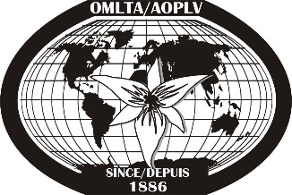
OMLTA’s Financial Literacy Writing Project

OMLTA is looking for enthusiastic elementary and secondary FSL teachers interested in updating the Financial Literacy document originally created in 2011.

Successful candidates will be educators who can speak to having embedded to Financial Literacy initiatives in the classroom practice and/or who are actively engaged in doing so during this academic year.

This project will include revising and/or rewriting the current financial literacy resource for Core French, Grades 4-12 as well as producing updated resources to build teacher capacity and understanding of Financial Literacy.

The revisions to this resource will include:
- connections to the current revised curricula with an emphasis on action-oriented, authentic tasks
- emphasis on oral language development and proficiency
- integration of technology to support student engagement and learning
- incorporation of the current financial literacy resources and materials
- implementation of current instructional, assessment and evaluation practices in second language acquisition
- integration of 21st century skills, including opportunities for inquiry-based learning
- a focus on fostering compassionate and responsible citizens

We are seeking:

- Two (2) elementary FSL teachers to work collaboratively on five lessons (one for each grade, grades 4 to 8). Each elementary teacher will be required to complete 15 days of work (5 lessons x 3 days per lesson)

- Four (4) secondary FSL teachers to write a total of eight (8) lessons (one for each of FSF1D, FSF1P, FSF2D, FSF2O, FSF3U, FSF3O, FSF4U, FSF4O). Each secondary teacher will write two lessons. Each secondary teacher will be required to complete 6 days of work (2 lessons x 3 days per lesson)

All writers will be paid $300/day of work completed.

The writing will take place in July and August.
Exchanging of ideas will take place electronically.
Work will be done from the comfort of home.

Please fill out the application form: http://goo.gl/forms/4jxbaijZcA

Deadline to apply: May 31, 2016

